TECHNOLOGY ARCHITECTURE

TRAIN DATA

SIGN LANGUAGE

Application Developed by FLASH UI

USER

MODEL



 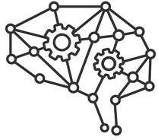

IMAGE PROCESSING

DATASET

TEAM ID: PNT2022TMID30648



TEXT / VOICE

TEST DATA